1. The initial situation is the need to contact the professor or TA about the assignment. The selection rules can vary based on the professor or the TA. Typically, Piazza is used to contact them, but email is also available if/when Piazza is not available. With Piazza and email, the methods are the same. Open Piazza or Email, write the message, and then click send. The difference with Piazza is that you need to ensure you are writing either a public question to everyone, or a private question only to the instructors of the course. The ultimate goal here is to alert the professor about the questions you have about grading.  
     
   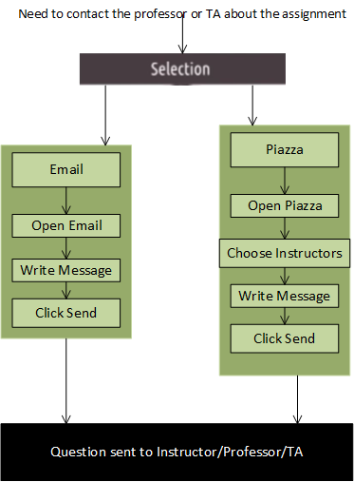
2. For the hierarchy to complete this assignment, I must first get the assignment. This involves opening T-Square and finding the assignment. Once found, I need to read the assignment and the instructions to complete as well as each question in the assignment to understand where it is going. Once I understand the assignment, I need to answer the questions, which creates a new state. I will need to review my notes from class, the lectures, and the reading materials in order to answer each question. I will need to write the answers down, and also format them to be clearly readable. Once I have answered the questions, I will need to format the document to the specifications set by the instructor, such as saving it as a PDF. Once that’s done, I can submit the assignment on T-Square. Once the grades are released, I need to log back into T-Square and review my grades. I could dive further and add a step to “Open T-Square” before reviewing the grade, but I left it out.  
   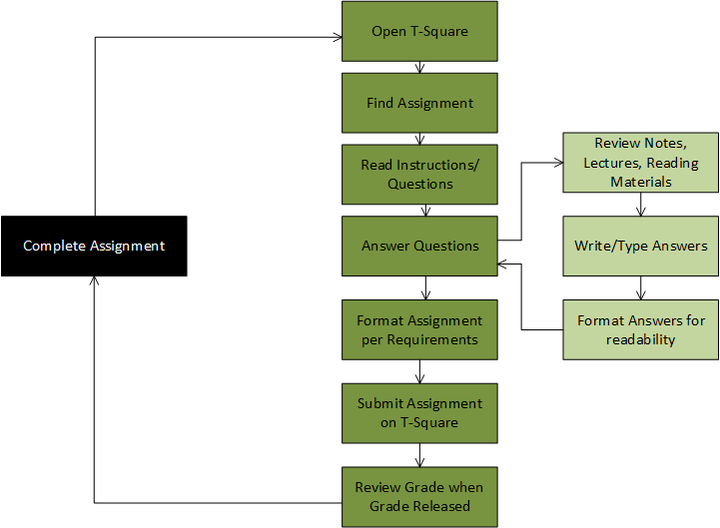
3. Being that my wife and I live in Montana, we are often times left without GPS on our devices as we enter areas without cellular service. While I am certain I know where we are going, my wife decides to pull out a map, a pen, and a notepad in order to write down the best route. We begin planning our best route. First, we need to figure out where we are. This is easy if we are at home, but if we have already left, then our short term memory is required for us to remember any landmarks or cities we have gone through. Now that we have our bearings, we have decided we want to take the shortest route possible. Using the map and the notepad, we can write down the different routes of journey on the notepad and calculate the millage for each route. The map gives us the perception of the routes and the notepad has now become an extension of our memory and helps to guide our reasoning as to which route is the shortest. Finally, we can start travelling. As we travel, the passenger would typically alert us as to how far to the next turn or marker on the map, along with what to do at that marker. The driver will head that direction and keep in their short term memory how far away it is. Once they’ve reached the marker and made the turn, the navigator and driver can then repeat these actions.  
     
   For social cognition, I could have spoken with a friend about a route that is shorter even though the map says differently. Doing so has allowed me to make better time on my route as well as revealing to me a better route when the map did not.
4. Previously, I’ve used my insulin pump as an interface in which I use quite often. The insulin pump’s interface is great. By entering in my current blood sugar and the amount of carbohydrates I’m about to eat, it does the math and tells me how much insulin I need. It also keeps in memory a list of previous blood sugars and insulin doses that I’ve taken. Furthermore, my insulin pump can estimate how much insulin I have left before I will need to refill it. It even has a clock to help me track the passage of time. These are all cognitive tasks performed by my pump. As far as the cognitive tasks I perform, I need to add up the amount of carbohydrates I plan on having at a meal, check my own blood sugar, and transfer that information to the pump. I also need to remember how to refill the pump with insulin. I need to know how to adjust the settings and insulin given if I plan on eating less or exercising as that can change the amount of insulin I require. It is a delicate balance of cognitive tasks between both the pump and I as a miscalculation in either could result in my injury or even death (not to be morbid, sorry if it seemed as such).

# Assignment P4

Due: Sunday, September 25th, 2016, by 11:59PM [UTC-12 (Anywhere on Earth)](https://www.timeanddate.com/time/zones/aoe). This assignment is based on lessons 2.7 (Task Analysis) and 2.8 (Distributed Cognition).

## Assignment Instructions

Answer the following four questions in a maximum of 300 words each (unless stated otherwise); if you supply more than 300 words, the grader will stop reading at the 300th word, and you will not receive credit for anything written after that. Clearly delineate where each answer starts and ends. You are encouraged but not required to complement your responses with diagrams, drawings, pictures, etc.; these do not count against the word limit, though any captions, text in tables, etc. does.

1. Create a thorough GOMS model for contacting a professor to ask for explanation of a grade. In doing so, make sure to (a) identify the initial situation, (b) describe the selection rules, (c) outline several methods, (d) identify the operators that comprise those methods, and (e) describe the ultimate goal. Your model should stand on its own; there should be no text supporting the answer to this question.
2. Create a hierarchical task analysis of the task of completing this assignment. This task analysis should cover everything from the initial reading of this assignment to receiving the grade. We would expect an adequately sufficient analysis to have at least five top-level tasks and at least three levels of hierarchy. Your model should stand on its own; there should be no text supporting the answer to this question.
3. Imagine a time before GPS navigation was as widespread as it is now, and think of the system for navigation comprised by two individuals (a married couple), a map, and any other artifacts the individuals generate. Analyze this system from the perspective of distributed cognition: what cognitive activities, including perception, memory, reasoning, and acting, does each part of the system perform (~175 words)? Then, examine this same situation from the perspective of social cognition. What does social cognition reveal about the situation that distributed cognition does not (~75 words)?
4. Distributed cognition is a lens through which we can view HCI. Take any interface you’ve described in a previous assignment for this class and analyze it from the perspective of distributed cognition. First, identify and briefly describe the interface you’ve chosen (~50 words). Then, describe the pieces of the system (~50 words). Then, describe what cognitive tasks are performed by each member of the system, both human and artifact alike (~150 words). The best answers will choose interfaces that touch on multiple cognitive roles in the non-human portions of the system.